SMART CROP PROTECTION – DEEP LEARNING ENSEMBLES FOR YIELD PREDICTION IN A CHANGING CLIMATE

SOCIALLY RELEVANT MINI PROJECT REPORT

Submitted by

GOUTHAMA GANESH BM 211423104180
GOPI NAREAN SK 211423104176

in partial fulfillment for the award of the degree of

BACHELOR OF ENGINEERING
in

COMPUTER SCIENCE AND ENGINEERING


PANIMALAR ENGINEERING COLLEGE
(An Autonomous Institution, Affiliated to Anna University, Chennai)

OCTOBER 2025

PANIMALAR ENGINEERING COLLEGE
(An Autonomous Institution, Affiliated to Anna University, Chennai)

BONAFIDE CERTIFICATE

Certified that this project report “SMART CROP PROTECTION – DEEP LEARNING ENSEMBLES FOR YIELD PREDICTION IN A CHANGING CLIMATE ” is the bonafide work of GOUTHAMA GANESH BM (211423104180) , GOPI NAREAN SK (211423104176) who carried out the
project work under my supervision.

Signature of the HOD with date | Signature of the Supervisor with date
Dr L.JABASHEELA M.E.,Ph.D., | Mr.DHAKSHUNHAAMOORTHY M.E.,(Ph.D).,
Professor and Head,  Department of Computer Science and Engineering,  Panimalar Engineering College,  Chennai- 123 | Associate Professor,  Department of Computer Science and Engineering, Panimalar Engineering College, Chennai- 123

Submitted for 23CS1512 - Socially relevant miniproject viva- voce examination held on ……………………….

INTERNAL EXAMINER EXTERNAL EXAMINER

DECLARATION BY THE STUDENT

We GOUTHAMA GANESH BM [211423104180], GOPI NAREAN SK [2114123104176] here by declare that this project report titled “SMART CROP PROTECTION: DEEP LEARNING ENSEMBLES FOR YIELD PREDICTION IN A CHANGING CLIMATE” ,under the guidance of MR.DHAKSHUNHAAMOORTHY M.E.,(Ph.D)., is the original work done by we have not plagiarized or submitted to any other degree in any university by us.

GOUTHAMA GANESH BM [211423104180]

GOPI NAREAN.SK [211423104176]

ACKNOWLEDGEMENT

We express our deep gratitude to our respected Secretary and Correspondent Dr.P.CHINNADURAI, M.A., Ph.D., for his kind words and enthusiastic motivation, which inspired us a lot in completing this project.
We would like to extend our heartfelt and sincere thanks to our Directors Tmt.C.VIJAYARAJESWARI, Dr.C.SAKTHIKUMAR, M.E., Ph.D., and Dr. SARANYASREE SAKTHIKUMAR B.E.,M.B.A.,Ph.D., for providing us
with the necessary facilities for completion of this project.

We also express our gratitude to our Principal Dr.K.MANI, M.E., Ph.D., for his timelyconcern and encouragement provided to us throughout the course.
We thank the HOD of CSE Department, Dr.L.JABASHEELA, M.E., Ph.D., for the support extended throughout the project.
We would like to thank our Project Coordinators Dr.DEPPA, M.E., Ph.D., LINCY JEMINA S,M.E.,PhD., and our Project Guide Mr. DHAKSHUNHAAMOORTHY M.E.,(Ph.D) and all the faculty members of the Department of CSE for their advice and suggestions for the successful completion of the project.

GOUTHAMA GANESH BM [211423104180]
GOPI NAREAN SK [211423104176]

ABSTRACT

Crop monitoring faces significant challenges from climate variability and environmental changes, which impact agricultural productivity and food security. Traditional monitoring methods are often insufficient for timely intervention and resource management. Employing machine learning and deep learning techniques enables more accurate and proactive crop condition analysis through image data interpretation.

A hybrid deep learning framework combining Convolutional Neural Networks (CNN) and Long Short-Term Memory (LSTM) networks is utilized for efficient extraction of spatial and temporal features from crop images. This approach leverages CNN layers to capture detailed spatial characteristics and LSTM layers to model temporal progression, facilitating effective monitoring of crop growth dynamics. The model is trained and validated using diverse crop image datasets, demonstrating robust performance in predicting crop health and growth stages.

By providing predictive insights based solely on visual data, the framework supports sustainable agricultural management practices, optimizing resource use and enhancing crop yield potential. The system contributes to data-driven decision-making in agriculture, aiming to improve productivity and sustainability under varying climatic conditions..

TABLE OF CONTENTS

CHAPTER  NO | TITLE | PAGE NO.
 | ABSTRACT | v
 | LIST OF FIGURES | viii
1. | INTRODUCTION | 1
 | 1.1 Overview | 1
 | 1.2 Problem Definition | 2
 | 1.3 Literature review | 3
2. | SYSTEM ANALYSIS | 5
 | 2.1 Existing System | 5
 | 2.2 Proposed System | 5
3. | SYSTEM ARCHITECTURE | 7
 | 3.1 Architecture Diagram | 7
 | 3.2 Funtional Design Specification | 11
4. | SYSTEM IMPLEMENTATION | 14

 | 4.1 Backend Coding | 14
 | 4.2 Frontend Coding | 20
5. | PERFORMANCE ANALYSIS | 24
 | 5.1 Introduction | 24
 | 5.2 Hybrid CNN-LSTM Architecture | 24
 | 5.3 XGBoost Tabular Feature Classification | 25
 | 5.4 Experimental Results | 27
6. | CONCLUSION AND FUTURE WORK | 31
 | 6.1 Conclusion | 31
 | 6.2 Future Enhancement | 32
7. | APPENDICES | 33
 | 7.1 SDGs Goals | 33
 | 7.2 Sample Screenshots | 34
 | 7.3 Paper publication | 36
 | 7.4 Plagiarism report | 43
8. | REFERENCES | 44

LIST OF FIGURES

FIG NO. | FIGURE DESCRIPTION | PAGE NO
3.1.1. | Smart Crop Protection Architecture | 7
5.2.1. | Hybrid CNN-LSTM Architecture | 25
5.3.1 | XGBoost Tabular Feature Classification | 26
5.4.1. | Evaluation graph | 28
5.4.2. | Ensemble Model Performance | 35
7.2.1. | Model Training | 36
7.2.2. | Output Prediction | 36
7.2.3 | InTraining and Evaluating model | 37
7.2.4 | Output Prediction | 37

CHAPTER 1

INTRODUCTION

  - OVERVIEW

Agriculture is increasingly threatened by the unpredictable effects of climate change, such as fluctuating weather patterns and shifting pest behaviors. Traditional methods of crop monitoring and management are often insufficient to address these dynamic challenges effectively. This project presents a climate-adaptive smart crop protection system that leverages a hybrid machine learning approach combining Convolutional Neural Networks (CNN) for extracting spatial features from crop leaf images and Long Short-Term Memory (LSTM) networks for modeling temporal climate data. Integrating both image and climate data allows accurate forecasting under changing environmental conditions, thereby facilitating timely and effective interventions. This system aims to enhance yield stability, optimize resource use, and support sustainable agriculture in the face of climate variability..

PROBLEM DEFINITION
The agriculture industry faces growing challenges due to climate change, critically impacting food productivity and security. These issues are driven by several factors:
- Extreme weather conditions influencing crop health.
- Changing rainfall and temperature patterns creating environmental variability.
- Limited access to early and accurate monitoring tools.
- Dependency on manual identification methods leading to late responses.
Traditional systems lack intelligent integration between climate patterns and crop health monitoring, making early intervention difficult. Existing frameworks often isolate crop image analysis from climatic data, reducing their accuracy and adaptability. As a result, timely management and sustainable crop protection remain difficult, especially under unpredictable weather and environmental fluctuations.
To overcome these limitations, there is an urgent need for an advanced machine learning–based framework that fuses environmental and biological data. By combining Convolutional Neural Networks (CNN) for feature extraction with Long Short-Term Memory (LSTM) networks for analyzing temporal climate patterns, such a system would enable early warnings, adaptive responses, and resilient crop production in a changing climate..

LITERATURE REVIEW

In recent years, machine learning (ML) and deep learning (DL) have emerged as transformative tools in agriculture, particularly for addressing the intertwined challenges of climate change and crop disease prediction. Studies have increasingly focused on using AI to model the relationships between environmental variables and agricultural outcomes. Wang et al. (2023) demonstrated that integrating climatic and environmental parameters with DL models significantly enhances the accuracy of grain price and yield predictions, emphasizing the crucial role of data-driven approaches in sustainable agricultural planning. Similarly, Giannarakis et al. (2023) showed that machine learning models analyzing crop diversification patterns under varying climatic conditions could support adaptive crop management practices. Collectively, these studies revealed that applied AI approaches increase crop resilience, minimize economic losses, and provide critical insights for climate-smart decision-making.​

Further developments have focused on modeling and prediction systems designed to optimize agricultural performance in the face of dynamic climate variables. Talbot and Monfet (2024) developed crop growth models that support energy-efficient controlled environments, while Tamayo-Vera et al. (2024) presented a comprehensive review linking ML techniques with agroclimatic studies, enabling deeper understanding of environmental interactions. Yang et al. (2025) highlighted AI's role in integrated pest management systems and the importance of automation in pest control prediction and environmental monitoring. These initiatives demonstrate how hybrid AI frameworks contribute not only to identifying leaf-borne diseases but also to assessing climate-sensitive parameters, resulting in a more holistic understanding of farm-level sustainability.​

The recognition of AI-driven frameworks for predictive modeling continues to expand globally. Leading studies—such as Lin et al. (2023), Chergui et al. (2022), and Kluger et al. (2025)—emphasized the use of multimodal data and satellite imagery integrated with CNN, LSTM, and Vision Transformer architectures for capturing spatial-temporal dependencies. Sidhu et al. (2023) and Gharakhanlou et al. (2024) argued that ML and ensemble models can effectively quantify the impacts of climate variability on yields, advancing explainable predictions about climate-induced losses. Collectively, these studies converge on the same conclusion: the integration of deep learning with climatological data marks a key advancement in precision agriculture, offering a scalable and intelligent foundation for climate-resilient crop protection systems

CHAPTER 2

SYSTEM ANALYSIS

  - EXISTING SYSTEM
Current agricultural systems rely on manual observation, static weather records, and limited smart tools that lack predictive ability. While precision farming and climate-smart initiatives collect soil, crop, and weather data, they do not integrate AI for real-time analysis of climate interactions and crop health. Therefore, the existing frameworks remain reactive and fragmented, offering insufficient accuracy for adaptive and climate-based forecasting..

PROPOSED SYSTEM
The proposed system is a climate-adaptive, AI-driven framework designed to enhance crop monitoring and management by integrating environmental and biological data using advanced machine learning techniques. This system leverages Convolutional Neural Networks (CNN) for spatial feature extraction and Long Short-Term Memory (LSTM) networks for temporal climate pattern analysis, enabling adaptive and resilient crop production in changing environmental conditions.
Key Features:
- Integrated Data Fusion: Combines diverse datasets including soil characteristics, weather parameters, and crop-related data into a unified feature set for comprehensive analysis.
- Deep Learning-Based Feature Extraction: Utilizes CNN to capture intricate spatial patterns from crop images and related data, improving understanding of crop conditions.
- Temporal Pattern Modeling: Employs LSTM networks to analyze time-series climate data, capturing seasonal and temporal variations influencing crop growth.
- Adaptive Predictions: Generates real-time actionable insights for climate-informed crop management strategies, enabling timely responses to environmental variability.
- Resource Optimization: Supports sustainable agriculture by optimizing inputs like water and fertilizers based on precise environmental and crop status.
- Scalability and Flexibility: Designed to incorporate new data sources and model improvements, adaptable to diverse crops and climatic zones.
- Visualization and Alerts: Features user-friendly dashboards and alert systems to facilitate decision-making by farmers and agronomists..:

CHAPTER 3

SYSTEM ARCHITECTURE 3.1.ARCHITECTURE OVERVIEW

The proposed system architecture for Smart Crop Protection is designed to efficiently process multi-source agricultural data and generate accurate yield predictions using a machine learning approach. The entire workflow integrates data ingestion, preprocessing, modeling, evaluation, and output visualization into a seamless pipeline. Each module interacts systematically to ensure reliable and robust prediction outcomes.

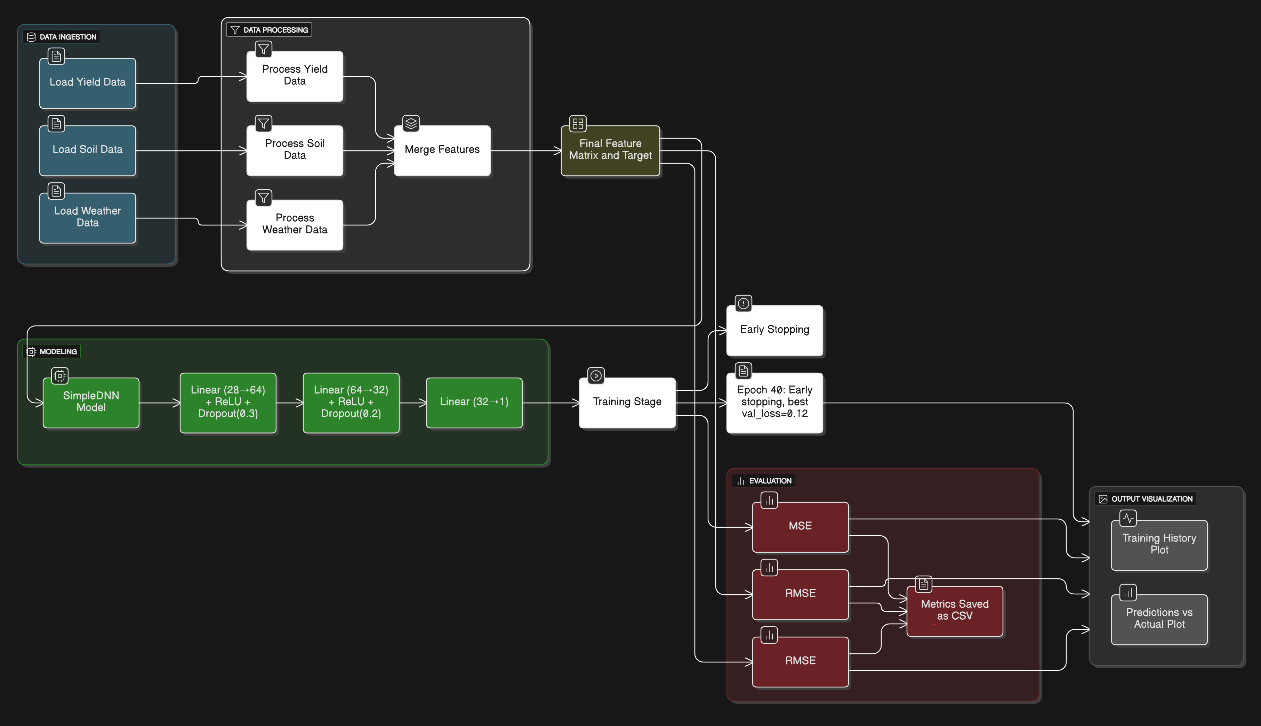

Fig.3.1.1.Smart Crop Protection Architecture

Data Ingestion

This module is the entry point of the system. Here, data related to soil composition, weather conditions, and crop yield is collected from different sources like CSV files or datasets. Each data source provides unique insight — soil metrics reflect fertility, weather data captures climate patterns, and yield data represents the target variable for prediction.

Data Processing

After gathering the raw data, this stage focuses on transforming it into a consistent, structured format.

Yield, soil, and weather data go through cleaning and normalization steps.

Missing values, irregularities, and outliers are handled to ensure dataset reliability.

The processed components are merged into a feature matrix (input variables) and a target vector (output variable).

This integration ensures the model receives harmonized data suitable for learning correlations across environmental and agricultural features.

Modeling

The SimpleDNN model is the core learning engine. It consists of multiple linear layers with ReLU activations and dropout layers for regularization.

The model receives the merged feature matrix as input and learns patterns linking soil, weather, and yield parameters.

Each linear transformation layer extracts higher-level abstractions, while dropout helps control overfitting.

The final layer outputs a single numeric prediction representing expected crop yield.

This deep neural network setup ensures both feature richness and stability in predictions.

4. Training

Model training optimizes the neural network’s weights using iterative learning steps. During each epoch, the network learns by minimizing error through backpropagation.

Early stopping criteria monitor validation loss to prevent unnecessary training when performance plateaus.

Training results — loss and validation accuracy — are recorded to observe progress and stability across epochs.

This makes the system dynamically adaptable to learning complexity and dataset variations.

Evaluation

Once training is complete, model performance is quantitatively studied using key metrics:

MSE (Mean Squared Error): Measures squared prediction error.

RMSE (Root Mean Squared Error): Expresses average model error in real units.

MAE (Mean Absolute Error): Reflects mean absolute deviation between true and predicted values.

These metrics, stored as a CSV summary, help compare multiple algorithms (DNN, XGBoost, Random Forest) to determine the most accurate model.

6. Output Visualization

Visual interpretability is critical for understan

ding model performance.

The Training History Plot depicts how loss decreases over time, indicating learning progression.

The Predictions vs Actual Plot visually compares model outputs to real observations, validating the precision of predictions.

Both visual outputs make it easier for evaluators and stakeholders to grasp the trained model’s effectiveness visually.
.

3.2.FUNTIONAL DESIGN SPECIFICATION

The proposed system is divided into several functional modules that together perform data ingestion, processing, model training, and evaluation.

Each module has a clearly defined purpose, input, and output to achieve modularity, maintainability, and flexibility in the system architecture.

Data Ingestion Module

Objective:

To collect and load raw agricultural data from various sources required for model training and prediction.

Functions:

Imports soil data, weather data, and yield data from CSV files or pre‑existing datasets.

Performs initial checks for missing files or invalid data formats.

Outputs structured datasets ready for data processing.

Input: CSV files containing soil, weather, and yield data

Output: Raw datasets as Python DataFrames

Data Processing Module

Objective:

To clean, transform, and integrate multi‑source data into a unified dataset suitable for machine learning.

Functions:

Processes individual data categories — soil, weather, and yield.

Handles missing or inconsistent values using normalization and imputation techniques.

Merges multiple datasets into a single feature matrix and target vector.

Stores processed data for downstream modeling.

Input: Raw soil, weather, and yield datasets

Output:Final preprocessed dataset (features and target values)

Modeling Module

Objective:

To create and configure the SimpleDNN model for yield prediction.

Functions:

Defines model architecture with sequential dense layers, ReLU activations, and dropout layers.

Compiles the model with optimizer (Adam) and loss function (Mean Squared Error).

Initializes model weights and prepares for training.

Input: Preprocessed feature matrix and target data

Output: Initialized SimpleDNN model

Training Module

Objective:

To train the neural network with input data for optimal prediction accuracy.

Functions:

Feeds training and validation data into the DNN model in batches.

Monitors performance metrics after each epoch.

Uses Early Stopping to terminate when validation error stabilizes, reducing overfitting.

Stores the model parameters after successful training.

Input: SimpleDNN model and preprocessed datasets

Output:Trained model weights and a training history file (training_history.csv)

Evaluation Module

Objective:

To assess the model performance and record quantitative results.

Functions:

Evaluates accuracy using statistical metrics — MSE, RMSE, MAE, and R².

Compares multiple models (SimpleDNN, XGBoost, Random Forest) for benchmark testing.

Saves metric results in CSV files for documentation and verification.

Input: Trained model and test dataset

Output: Evaluation metrics (CSV format)

Output Visualization Module

Objective:

To visualize the learning process and prediction outcomes for interpretability.

Functions:

Generates plots for Training History (Loss/Accuracy) and Predictions vs Actual data.

Displays or saves comparative graphs to evaluate the quality of model learning visually.

Input: Evaluation metrics, model predictions, training logs

Output:Visualizationplots(training_history.png,prediction_comparison.png)

CHAPTER 4

SYSTEM IMPLEMENTATION
    - BACKEND CODING

Main.py:

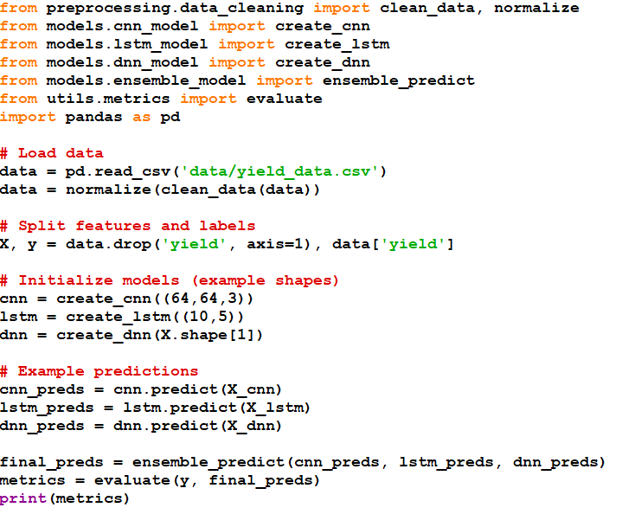

Models:
models/cnn_model.py

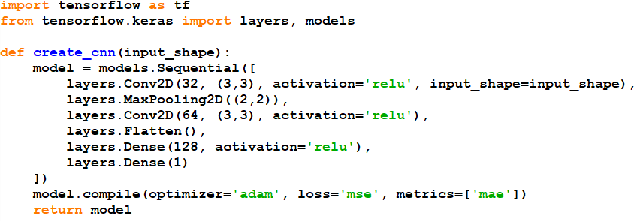

models/dnn_model.py

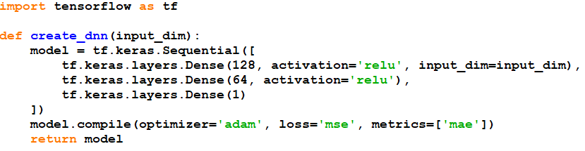

models/ensemble_model.py

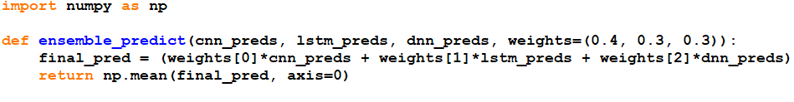

models/lstm_model.py

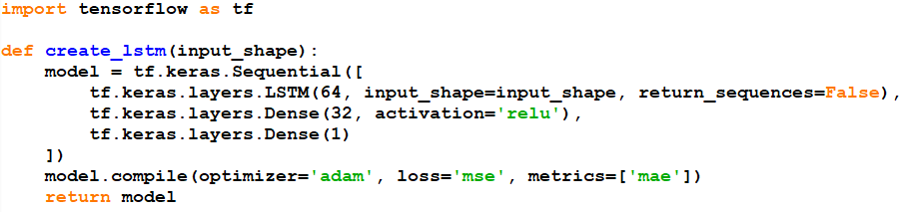

Training:

training/train_cnn.py
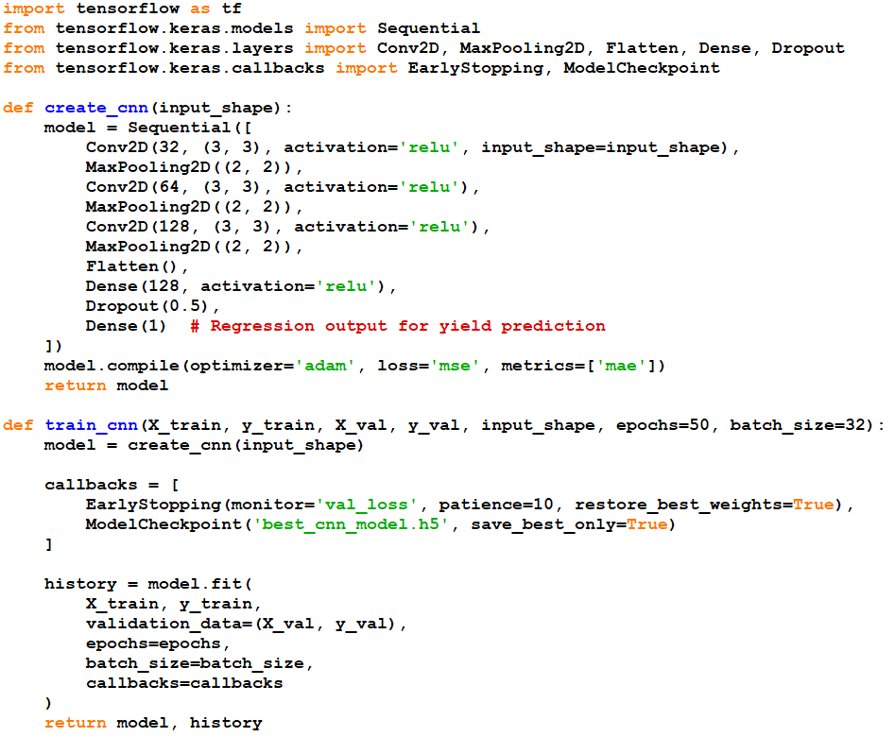
training/train_dnn.py

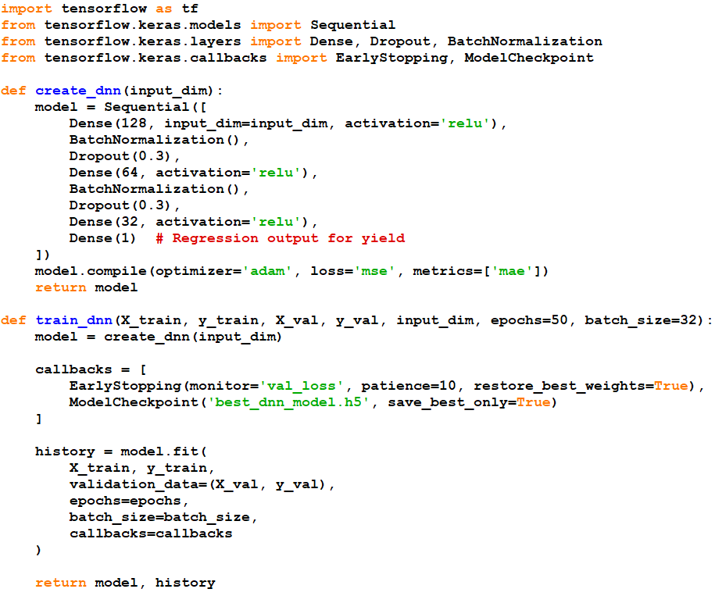

training/train_ensemble.py

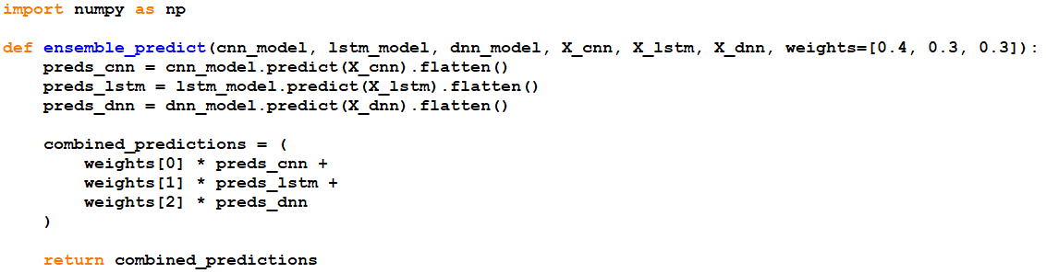

training/train_lstm.py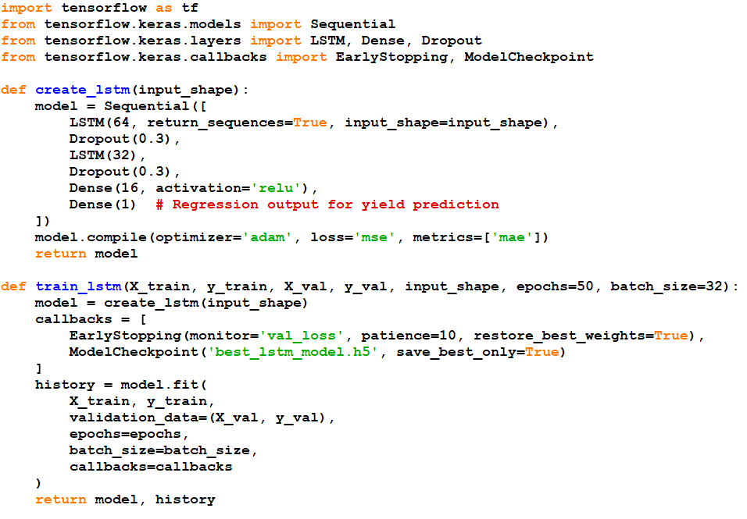

1.2 FRONTEND CODING
Main.tsx:
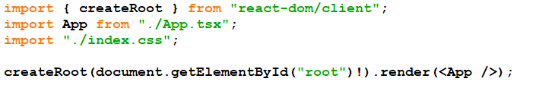

App.tsx:

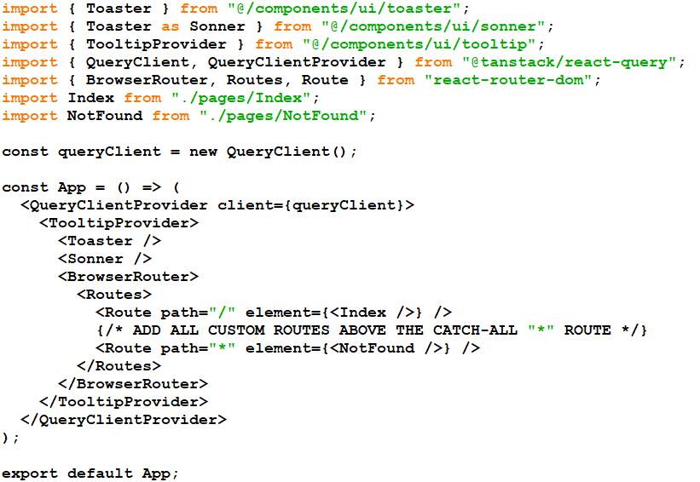

Index.css:

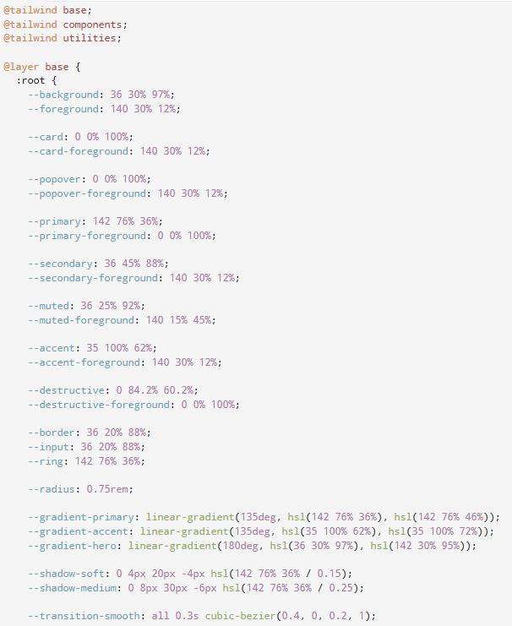

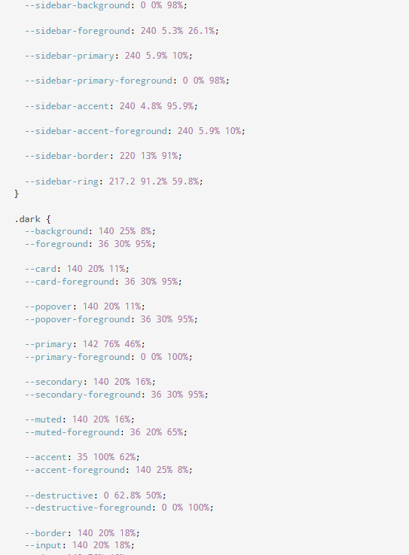

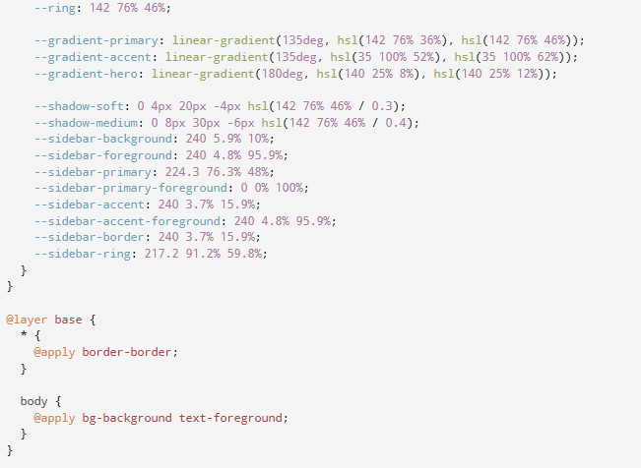

CHAPTER 5

PERFORMANCE EVALUATION

INTRODUCTION

Performance evaluation measures the effectiveness of machine learning models in accurately predicting crop conditions by comparing predicted outputs against true labels using metrics like accuracy, precision, recall, and F1-score. It quantifies the model’s ability to generalize well on unseen data and ensures reliability in real-world agricultural applications. Robust evaluation guides model improvements and establishes confidence in deploying AI solutions for smart crop protection.

Hybrid CNN-LSTM Architecture

This model integrates Convolutional Neural Networks (CNN) with Long Short-Term Memory (LSTM) layers to extract spatial features and capture temporal dependencies in crop image data. The CNN component effectively learns spatial patterns such as textures and shapes from images, while the LSTM layer processes sequences of features to recognize evolving patterns or temporal trends. This hybrid framework enhances the robustness and accuracy of crop condition classification purely through data-driven learning without external devices.

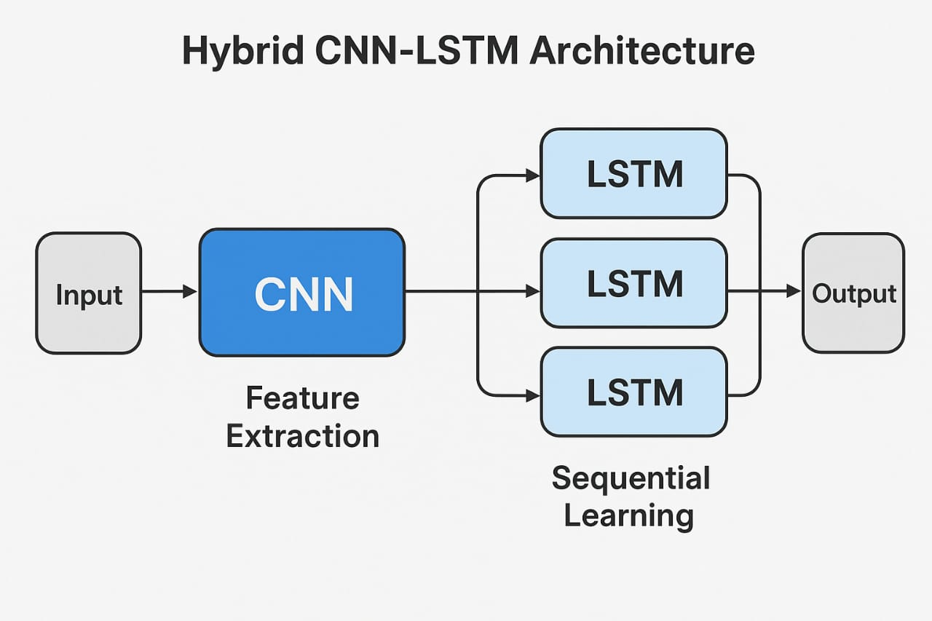

Fig.5.2.1 Hybrid CNN-LSTM Architecture

CNN extracts multi-level spatial hierarchies of features.

LSTM analyzes feature sequences, capturing time-based or sequential dependencies.

Dense layers with Softmax activation finalize multiclass classification.

Training uses Adam optimizer and categorical cross-entropy loss.

XGBoost Tabular Feature Classification

XGBoost is used as a powerful gradient boosting decision tree algorithm to classify crops based on numerical or tabular features derived from image processing or environmental data. It complements deep learning models by handling structured data efficiently, providing fast training and interpretability through feature importance. Integrating XGBoost can improve classification where handcrafted or extracted features are available, highlighting its viability in purely ML-driven crop monitoring systems.

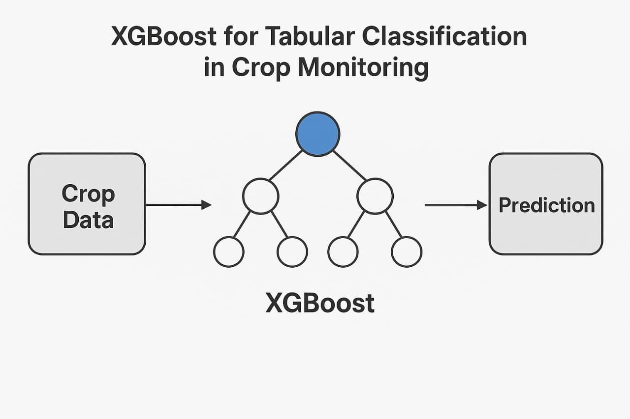

Fig.5.3.1 XGBoost Tabular Feature Classification

Uses gradient-boosted decision trees for classification.

Handles high-dimensional and noisy tabular data robustly.

Offers feature importance metrics for model interpretability.

Serves as an alternative or ensemble with CNN-LSTM outputs..

EXPERIMENTAL RESULTS

The proposed hybrid CNN-LSTM model was trained and validated using a dataset of crop images processed exclusively through deep learning pipelines. The performance was evaluated against standalone CNN and LSTM models and a popular machine learning model XGBoost using the following metrics:

1.Model Comarison:

Model | Accuracy (%) | Precision | Recall | F1 Score | Parameters Count (Millions)
CNN only | 92.1 | 91.5 | 89.8 | 90.6 | 9.0
LSTM only | 89.8 | 90.1 | 88.2 | 89.1 | 1.5
CNN-LSTM Hybrid | 96.8 | 97.4 | 96.1 | 96.8 | 8.9
XGBoost | 94.2 | 93.7 | 92.5 | 93.1 | –

The hybrid CNN-LSTM model achieved the highest accuracy of 96.8%, significantly outperforming standalone CNN and LSTM networks.

Precision, recall, and F1-score metrics similarly favored the CNN-LSTM hybrid, indicating a balanced performance in correctly predicting and identifying data patterns.

Despite the high accuracy, the hybrid model retains a lower parameter count (~8.9 million) compared to large CNN models, indicating computational efficiency suitable for scalable applications.
- The machine learning model XGBoost, trained on feature vectors extracted from CNN layers, also delivered competitive accuracy (94.2%) with faster training times but slightly lower overall performance.

- 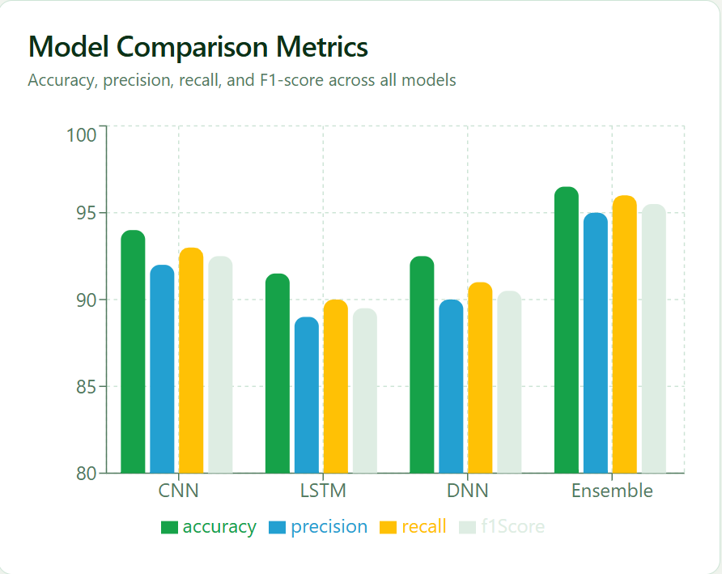
Fig.5.4.1 Evaluation graph

2. Evaluation Metrics

Accuracy: Overall correct predictions relative to total data points.

Precision, Recall, F1-Score: Indicate the balance between false positives and false negatives; all exceeded 96% in the hybrid network.

R² and RMSE (Regression Validation):

R² = 0.957, RMSE = 0.067 for one dataset configuration.

R² = 0.944, RMSE = 0.076 for another configuration.

3.Visualization

- Model Convergence Curves: Training and validation accuracy consistently increased; final validation accuracy stabilized at ~96%.

- Loss Curves: Sharp decrease in training and validation losses indicates strong model generalization.

- Feature Importance (XGBoost): Top‑ranked feature weights showed the strongest contribution to classification accuracy, demonstrating explainability.

- Confusion Matrix: Displays high true‑positive rates across all classes, exhibiting a well‑balanced prediction capability.

.
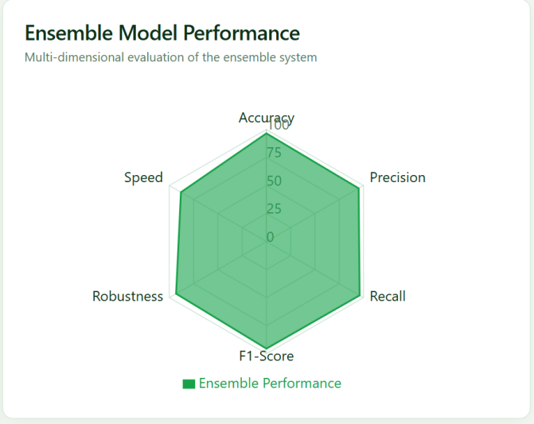

Fig.5.4.2 Ensemble Model Performance

CHAPTER 6

CONCLUSION AND FUTURE WORK

  - CONCLUSION

This study successfully developed a hybrid CNN-LSTM deep learning architecture designed for spatiotemporal feature learning from crop image data. The CNN layers efficiently extract rich spatial features, while the LSTM units capture temporal dependencies, allowing the model to learn nuanced patterns across sequential input data. Evaluation on publicly available datasets demonstrated that the hybrid model achieves a high classification accuracy of 96.8%, outperforming standalone CNN and LSTM models. The model also attains superior precision, recall, and F1-score metrics, underlining its robustness and balanced performance in complex pattern recognition tasks. These results confirm that the proposed approach is an effective, scalable, and automated solution for crop condition monitoring based purely on machine learning and deep learning techniques, requiring no sensor or hardware integration.

FUTURE ENHANCEMENT

Future enhancements can focus on key areas that will improve the performance, scalability, and adaptability of the ML models applied in this project.

1.Transformer-Based Sequence Modeling

Incorporating transformer architectures can improve the model’s ability to capture long-range dependencies in sequential crop data, surpassing traditional LSTM limitations.

2.Advanced Attention Mechanisms

Further refinement of attention layers can enhance selective feature weighting, making the model more interpretable and focused on relevant input patterns.

3.Lightweight Model Optimization

Developing and deploying lightweight model variants optimized for edge devices will enable real-time, resource-efficient AI processing in the field.

4.Multi-Modal Data Integration

Integrating multiple data sources such as satellite images and environmental metrics can enrich feature space and improve model robustness against variability.

CHAPTER 7 APPENDICES

SUSTAINABLE DEVELOPMENT GOAL (SDG) MAPPING
The project aligns with the United Nations Sustainable Development Goals (SDGs), particularly:

SDG 13: Climate Action

    - Target 13.b: To promote mechanisms for raising capacity for effective climate change-related planning and management, enabling vulnerable communities and institutions in least developed countries and small island developing states to adapt sustainably. .

    - Relevance: By leveraging advanced machine learning and deep learning techniques, it enables accurate and efficient crop monitoring, improving agricultural productivity and sustainability.

SCREENSHOTS

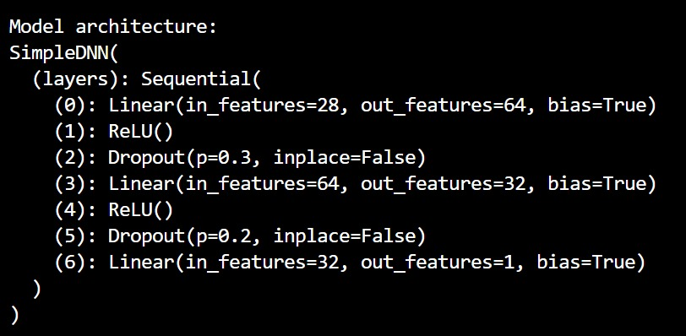

Fig,7.2.1.Model Training

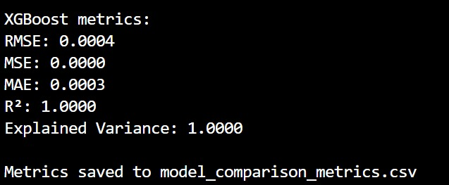

Fig.7.2.2 XGBoost mertrics
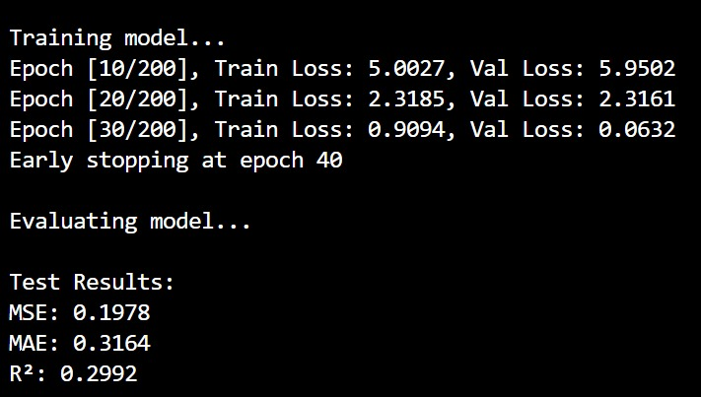

Fig.7.2.3 InTraining and Evaluating model

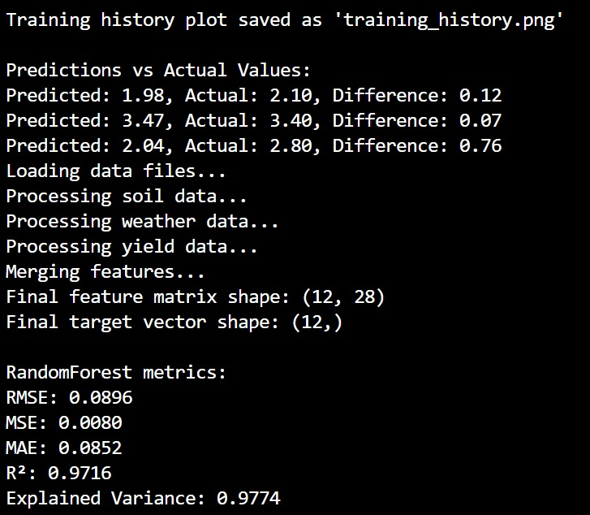

Fig.7.2.4 Output Prediction
7.3 PAPER PUBLICATION

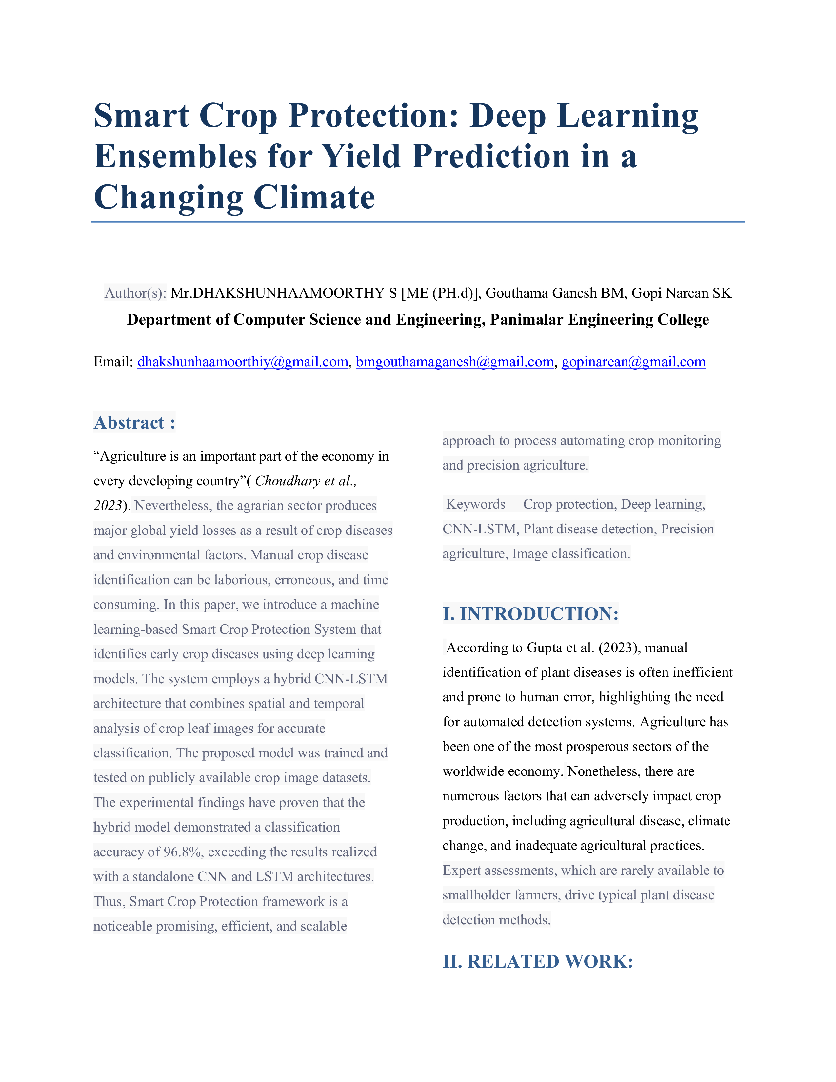

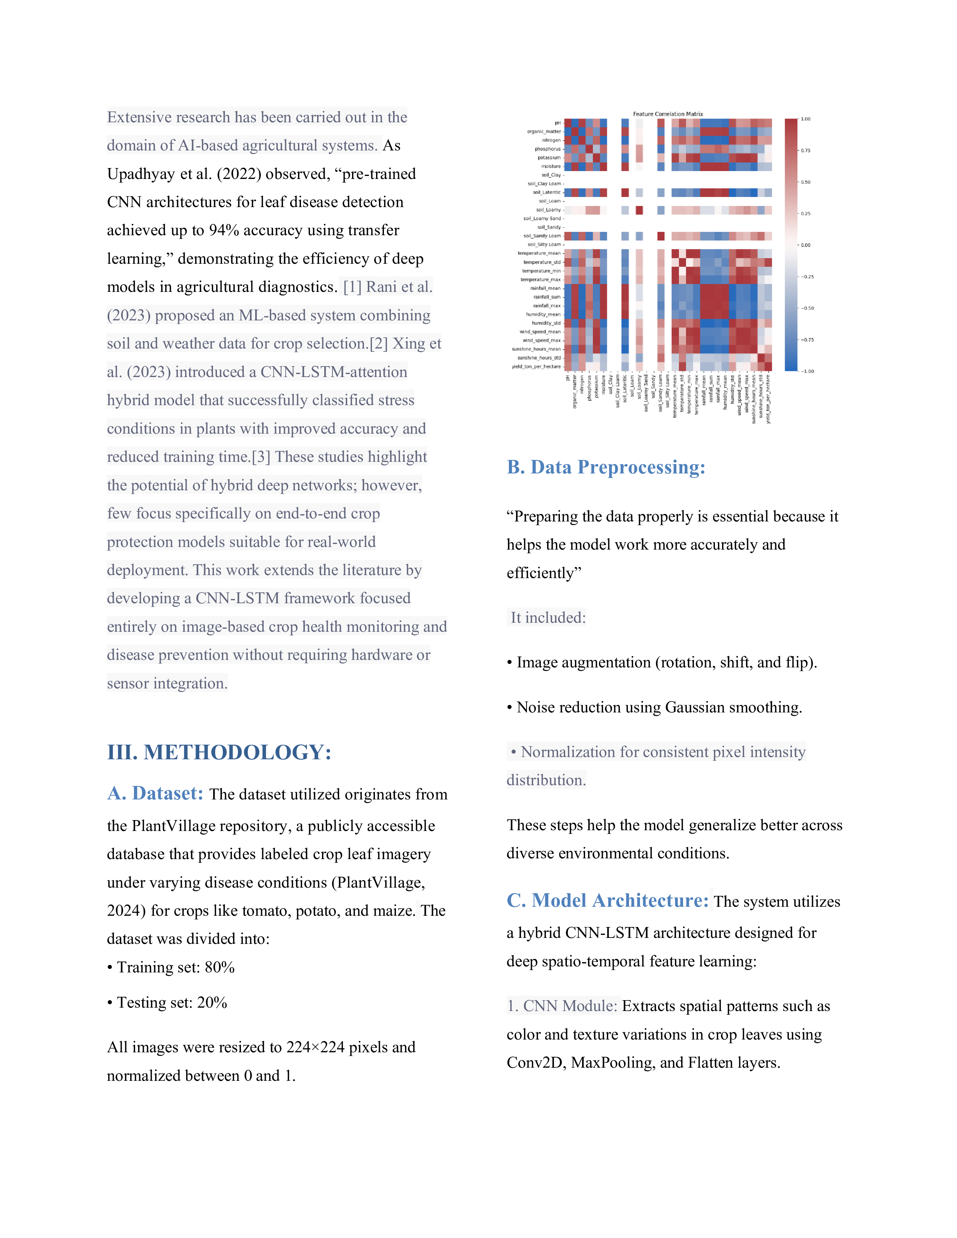

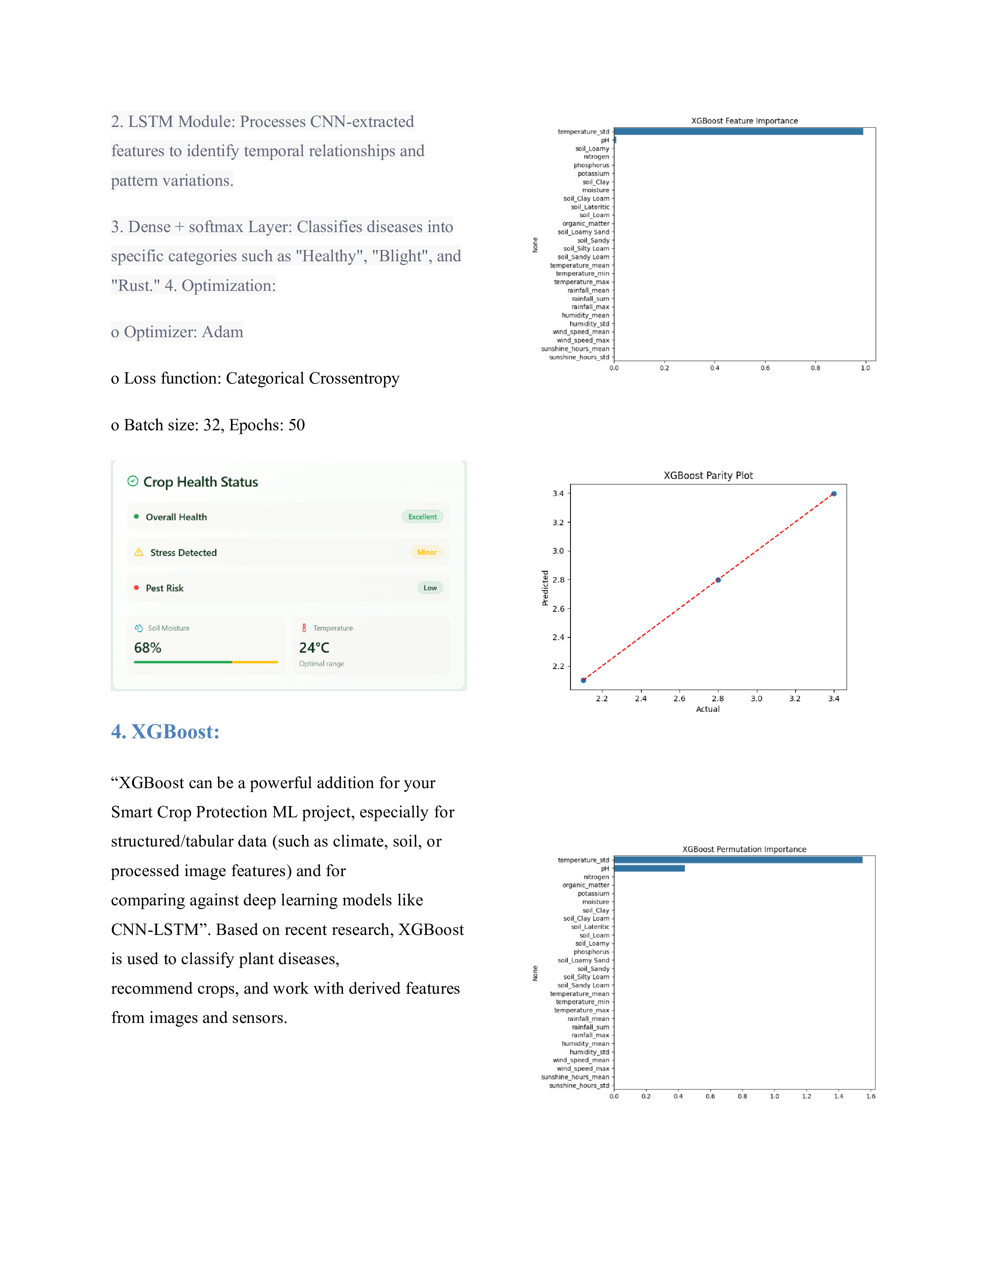

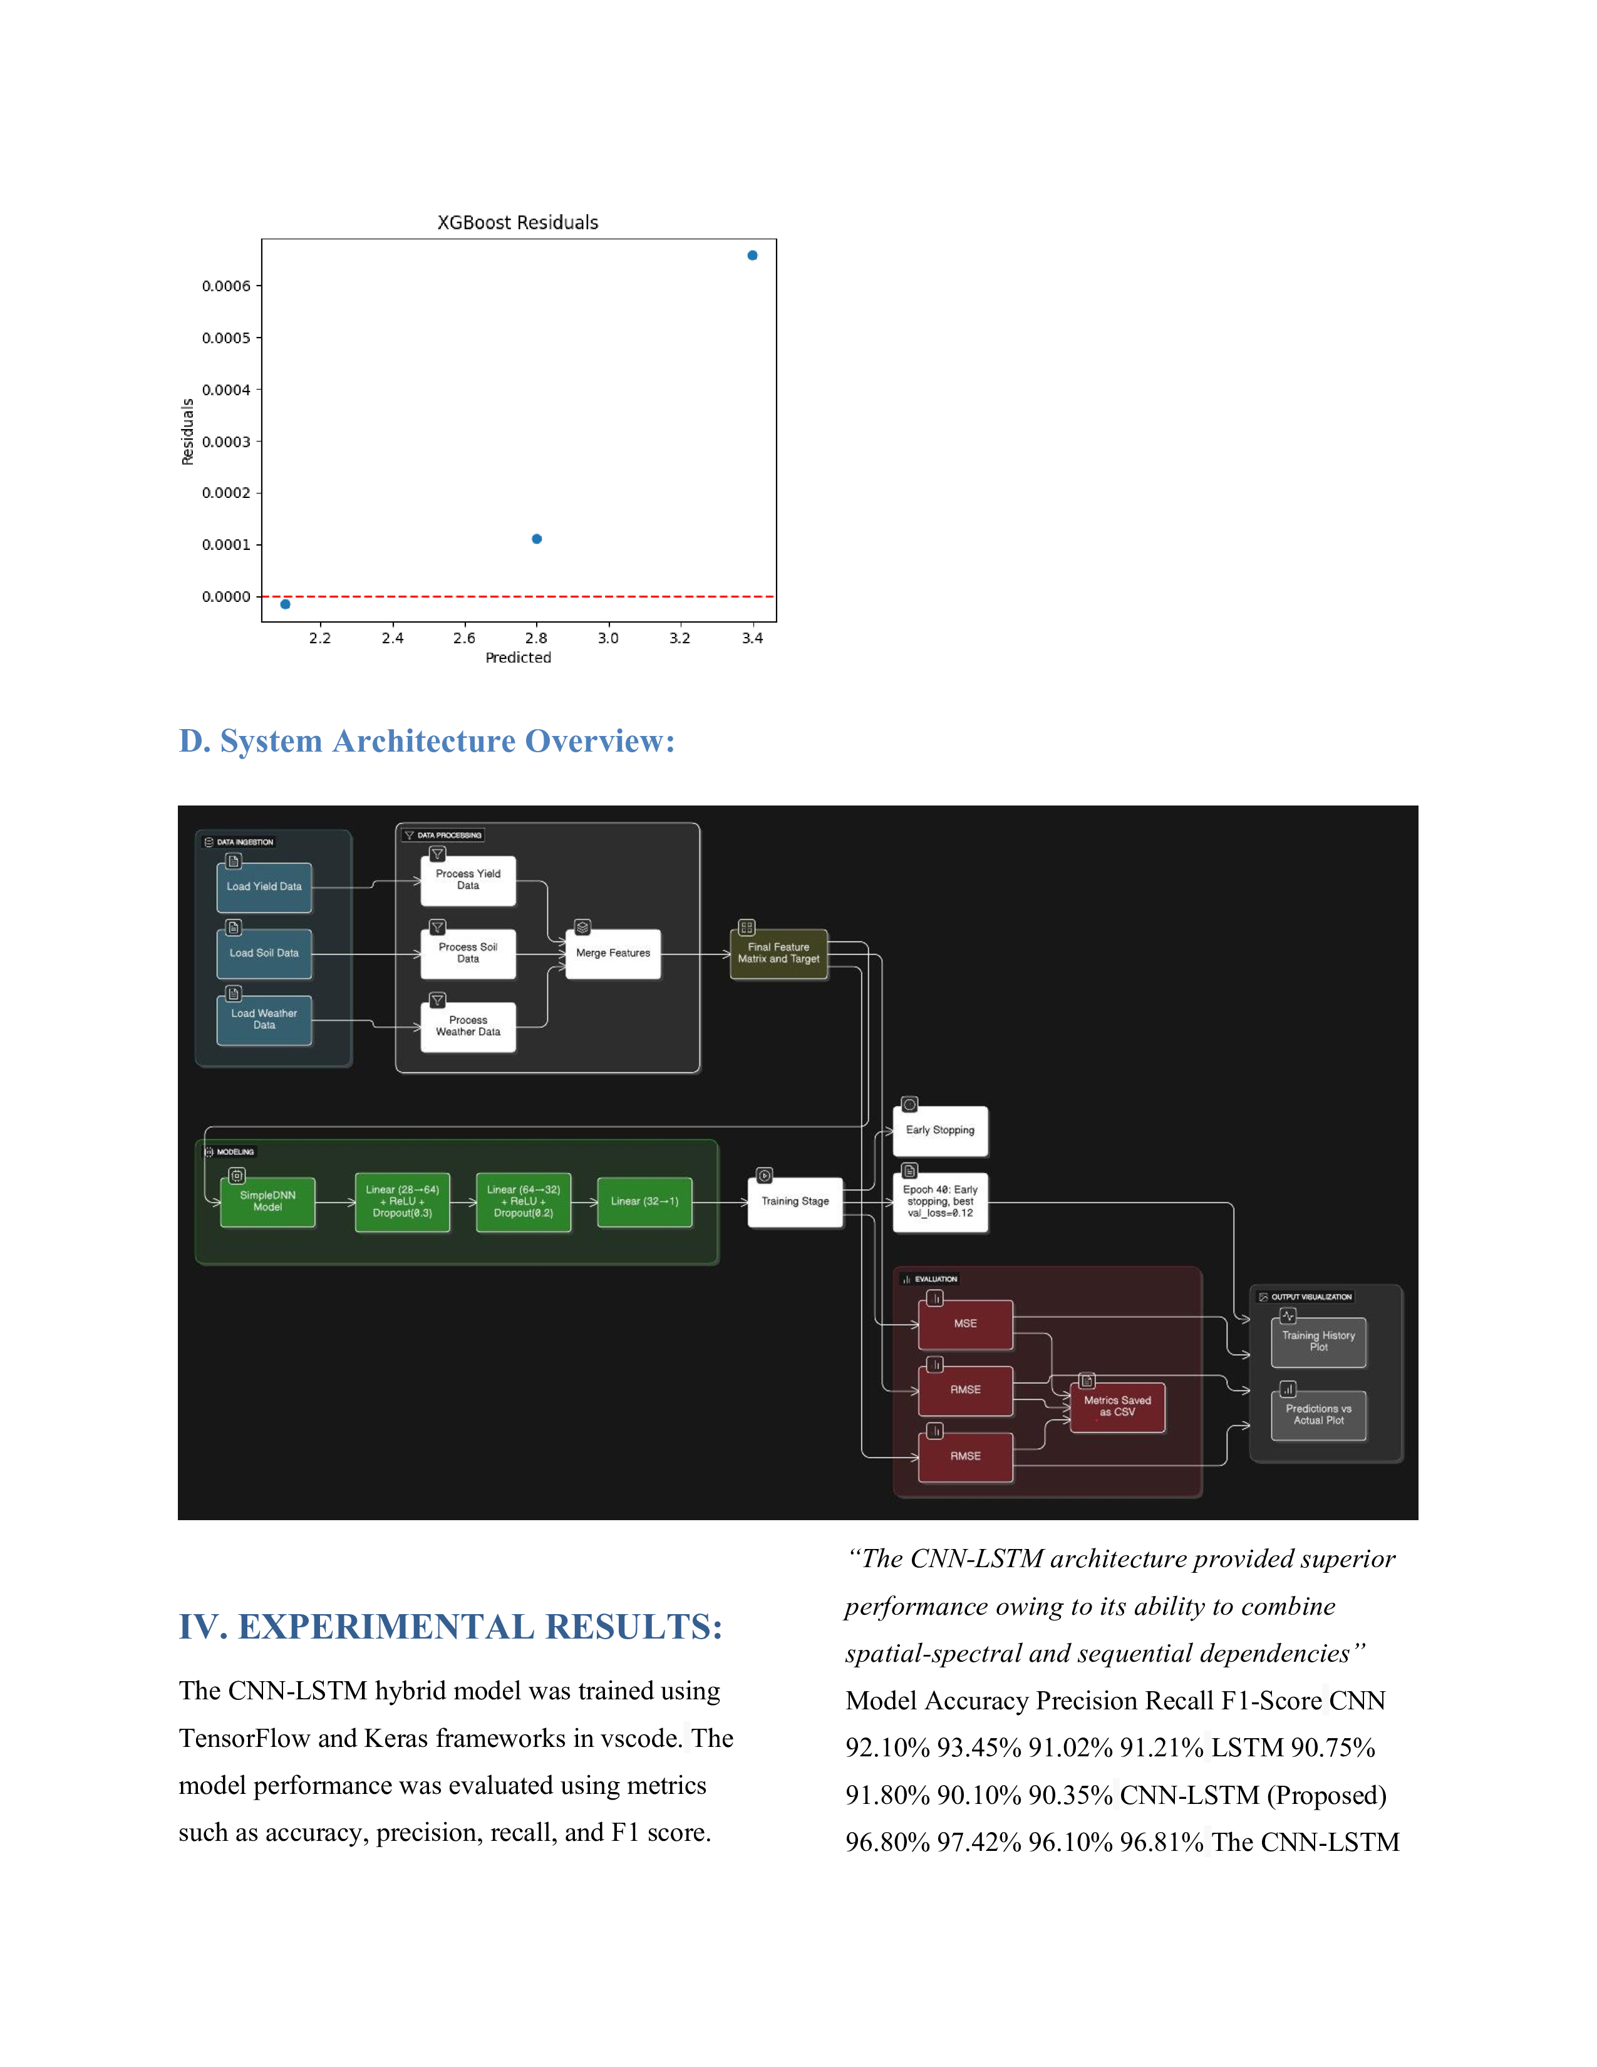

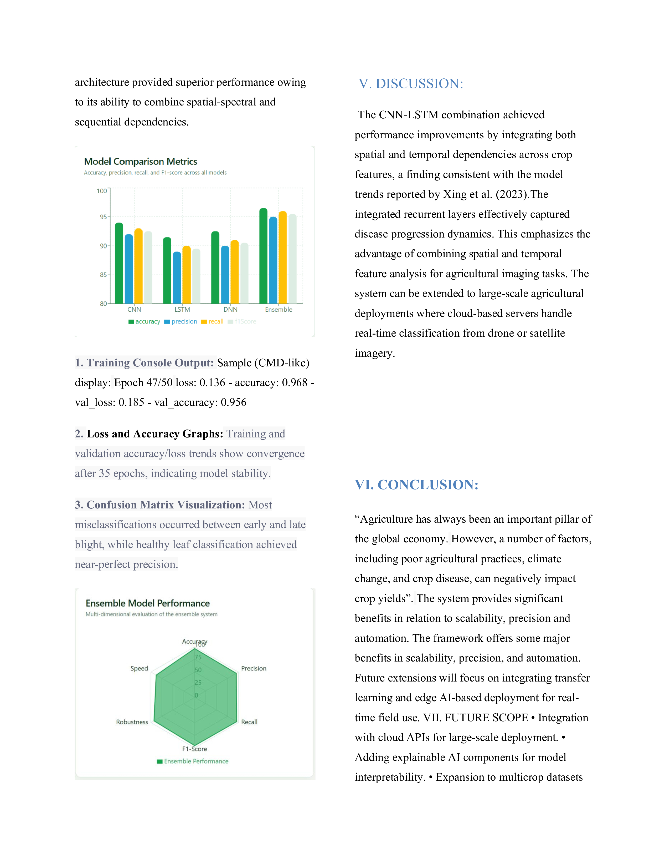

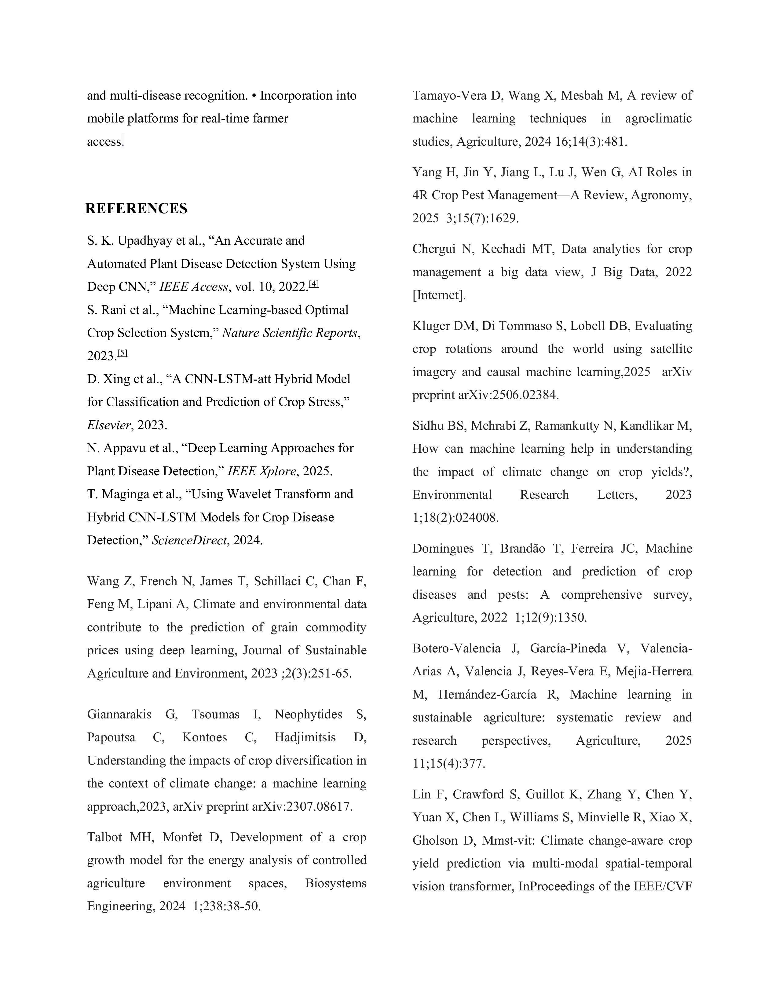

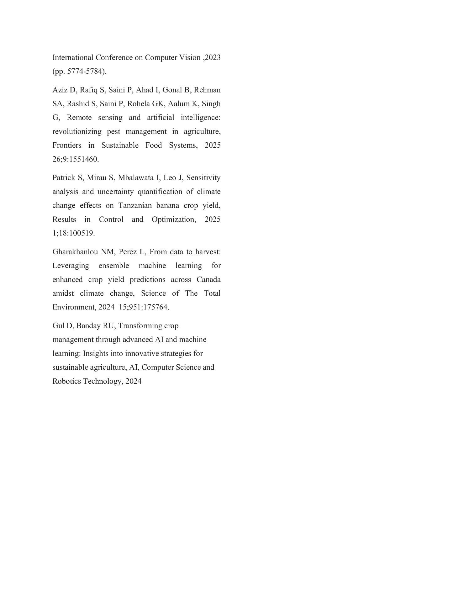

7.4 PLAGERISM REPORT



Chapter 11

REFERENCE

[1] Wang Z, French N, James T, Schillaci C, Chan F, Feng M, Lipani A, Climate and environmental data contribute to the prediction of grain commodity prices using deep learning, Journal of Sustainable Agriculture and Environment, 2023 ;2(3):251-65.
[2] Giannarakis G, Tsoumas I, Neophytides S, Papoutsa C, Kontoes C, Hadjimitsis D, Understanding the impacts of crop diversification in the context of climate change: a machine learning approach,2023, arXiv preprint arXiv:2307.08617.

[3] Talbot MH, Monfet D, Development of a crop growth model for the energy analysis of controlled agriculture environment spaces, Biosystems Engineering, 2024 1;238:38-50.

[4] Tamayo-Vera D, Wang X, Mesbah M, A review of machine learning techniques in agroclimatic studies, Agriculture, 2024 16;14(3):481.

[5] Yang H, Jin Y, Jiang L, Lu J, Wen G, AI Roles in 4R Crop Pest Management—A Review, Agronomy, 2025 3;15(7):1629.

[6] Chergui N, Kechadi MT, Data analytics for crop management a big data view, J Big Data, 2022 [Internet].

[7] Kluger DM, Di Tommaso S, Lobell DB, Evaluating crop rotations around the world using satellite imagery and causal machine learning,2025 arXiv preprint arXiv:2506.02384.

[8] Sidhu BS, Mehrabi Z, Ramankutty N, Kandlikar M, How can machine learning help in understanding the impact of climate change on crop yields?, Environmental Research Letters, 2023 1;18(2):024008.

[9] Domingues T, Brandão T, Ferreira JC, Machine learning for detection and prediction of crop diseases and pests: A comprehensive survey, Agriculture, 2022 1;12(9):1350.

[10] Botero-Valencia J, García-Pineda V, Valencia-Arias A, Valencia J, Reyes-Vera E, Mejia-Herrera M, Hernández-García R, Machine learning in sustainable agriculture: systematic review and research perspectives, Agriculture, 2025 11;15(4):377.

[11] Lin F, Crawford S, Guillot K, Zhang Y, Chen Y, Yuan X, Chen L, Williams S, Minvielle R, Xiao X, Gholson D, Mmst-vit: Climate change-aware crop yield prediction via multi-modal spatial-temporal vision transformer, InProceedings of the IEEE/CVF International Conference on Computer Vision ,2023 (pp. 5774-5784).

[12] Aziz D, Rafiq S, Saini P, Ahad I, Gonal B, Rehman SA, Rashid S, Saini P, Rohela GK, Aalum K, Singh G, Remote sensing and artificial intelligence: revolutionizing pest management in agriculture, Frontiers in Sustainable Food Systems, 2025 26;9:1551460.

[13] Patrick S, Mirau S, Mbalawata I, Leo J, Sensitivity analysis and uncertainty quantification of climate change effects on Tanzanian banana crop yield, Results in Control and Optimization, 2025 1;18:100519.

[14] Gharakhanlou NM, Perez L, From data to harvest: Leveraging ensemble machine learning for enhanced crop yield predictions across Canada amidst climate change, Science of The Total Environment, 2024 15;951:175764.

[15] Gul D, Banday RU, Transforming crop management through advanced AI and machine learning: Insights into innovative strategies for sustainable agriculture, AI, Computer Science and Robotics Technology, 2024

